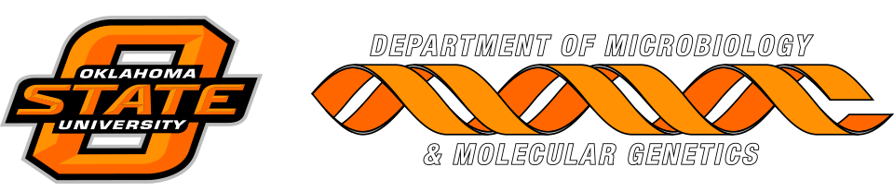

MICROBIOLOGY & MOLECULAR GENETICS
SEMINAR

2017 Vennerberg Lecture
“Metagenomics explorations to new branches on the tree of life”

Dr. Brett Baker
Assistant Professor
Marine Science Institute
University of Texas at Austin
Monday
March 27, 2017
3:30pm
RM LSE 215
Chalk Talk in HBRC 130J at 1:30 pm

