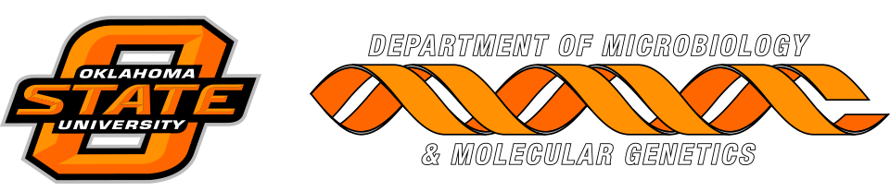

MICROBIOLOGY & MOLECULAR GENETICS
SEMINAR
“Development of alternatives to antibiotics: immune modulation or microbiome manipulation?”

Dr. Glenn Zhang
Professor
Boulware Endowed Chair
Department of Animal Science
Oklahoma State University
Monday April 17, 2017
3:30pmRM
LSE 215

