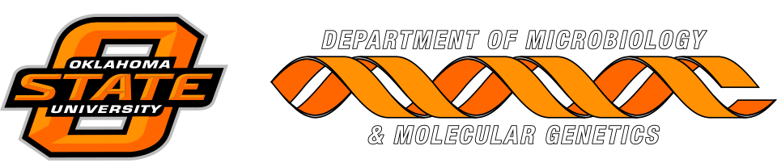

MICROBIOLOGY & MOLECULAR GENETICS
SEMINAR
“Ecological stoichiometry beyond Redfield: Understanding ionomes”
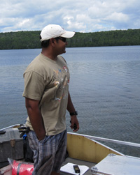
Puni Jeyasingh
Professor
Integrative Biology
OSU University
Monday
October 23 2017
3:30pm
RM LSE 215

