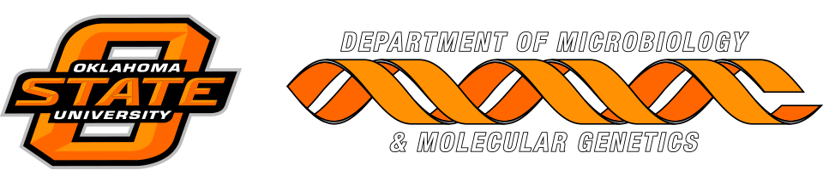

MICROBIOLOGY & MOLECULAR GENETICS
SEMINAR
“Top-down MS and functional proteomics”
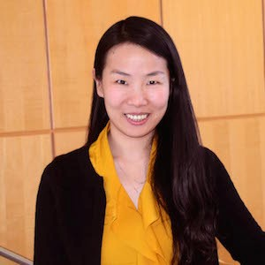
Si Wu
Assistant Professor
Dept. Chemistry & Biochemistry
OU University
Monday
October 16 2017
3:30pm
RM LSE 215

