MICROBIOLOGY & MOLECULAR GENETICS
SEMINAR
“Taking the pulse of flagellum synthesis in a single bacterium”
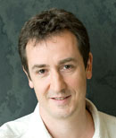
Philippe Cluzel, PhD
Dept of Molecular & Cellular Biology
Harvard University
Monday
March 5, 2018
3:30pm
RM LSE 215

