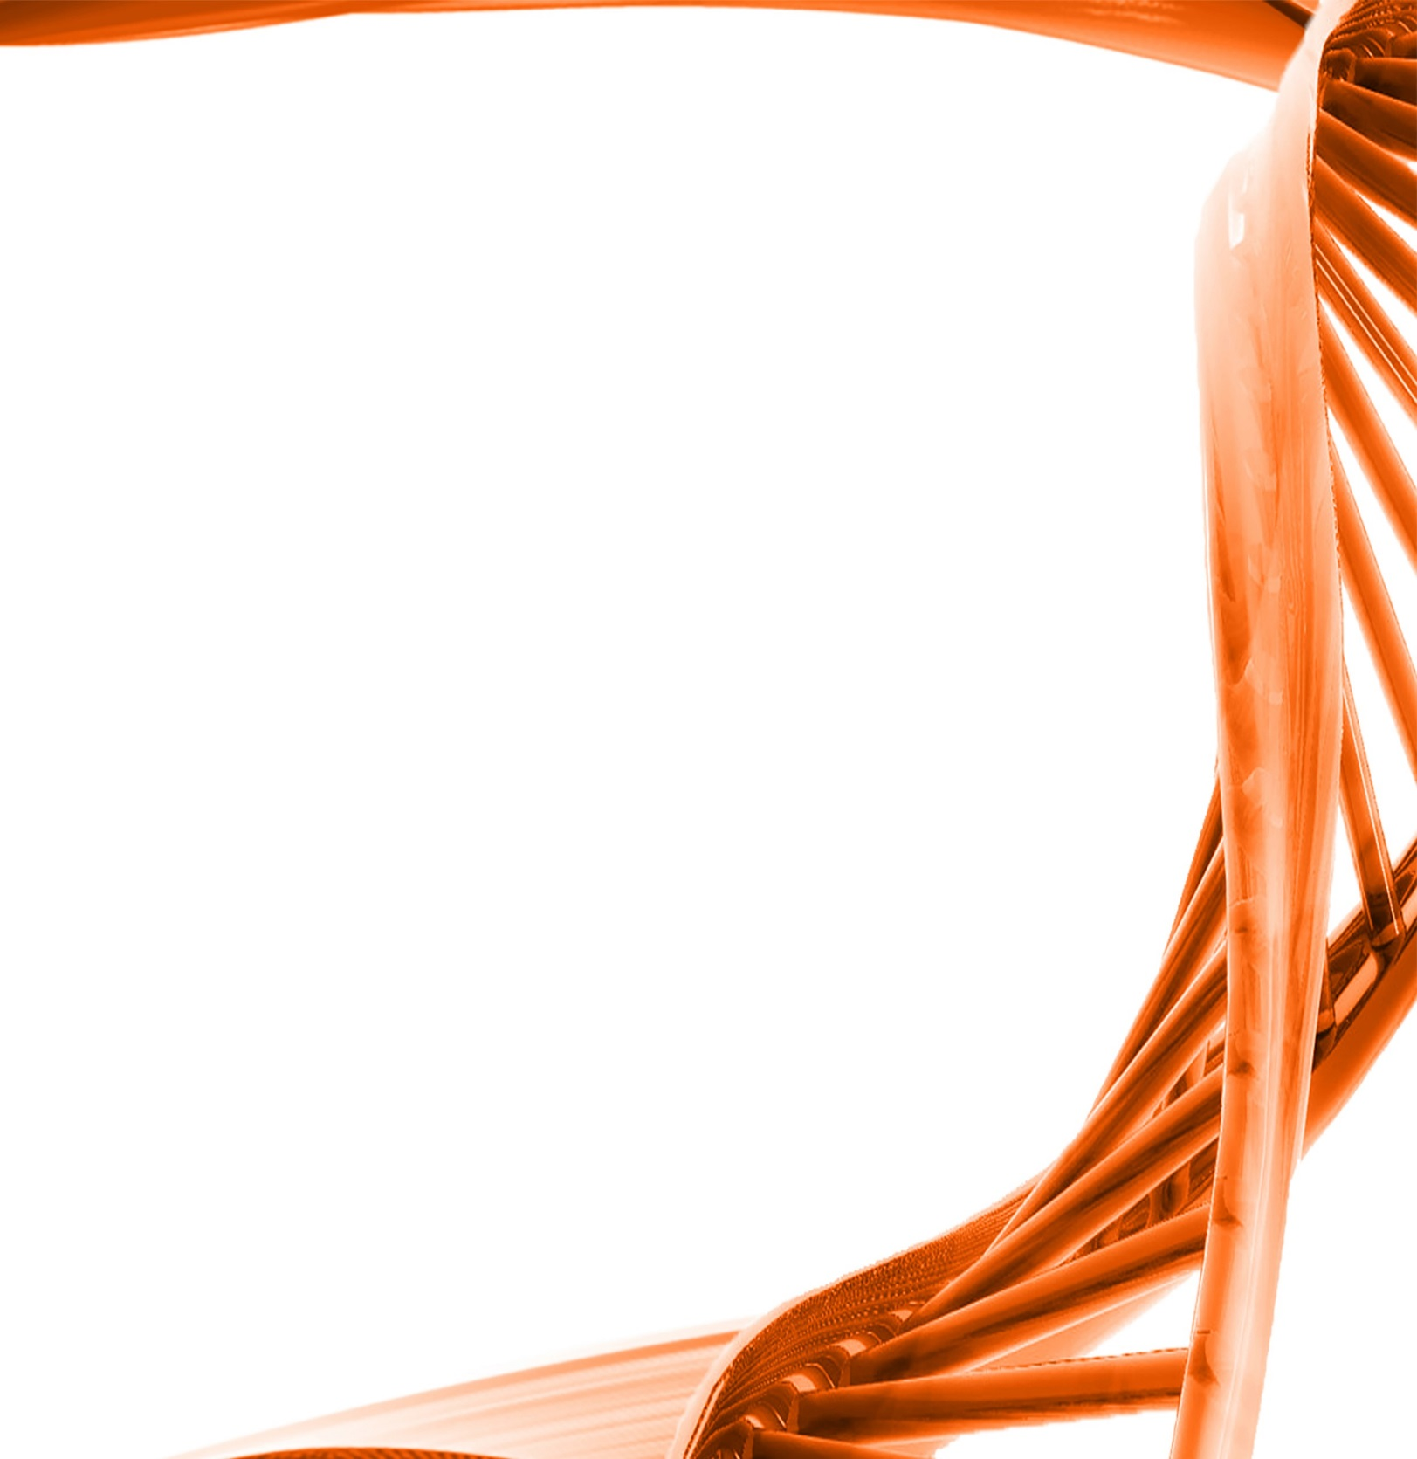
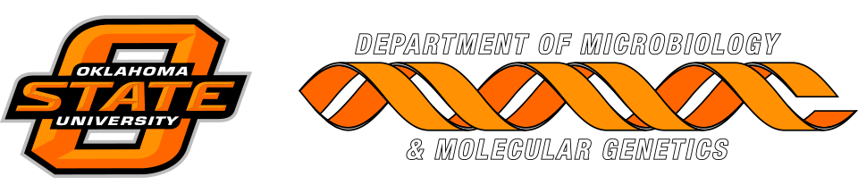

MICROBIOLOGY & MOLECULAR GENETICS
SEMINAR

“Stimulation of microbial methanogenesis from oil and CO₂ in the Cushing oil field”

Dr. Javier Vilcaez Perez
Assistant Professor
Boone Pickens School of Geology
Monday
February 20th, 2017
3:30pm
RM LSE 215

