MICROBIOLOGY & MOLECULAR GENETICS
SEMINAR
“Diversity and dynamics in phototrophic communities”
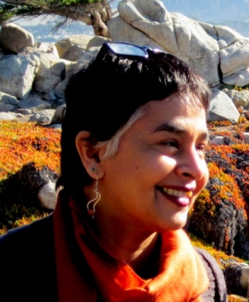
Devaki Bhaya, PhD
Plant Biology Dept.
Carnegie Institution for Science
Monday
February 12, 2018
3:30pm
RM LSE 215

