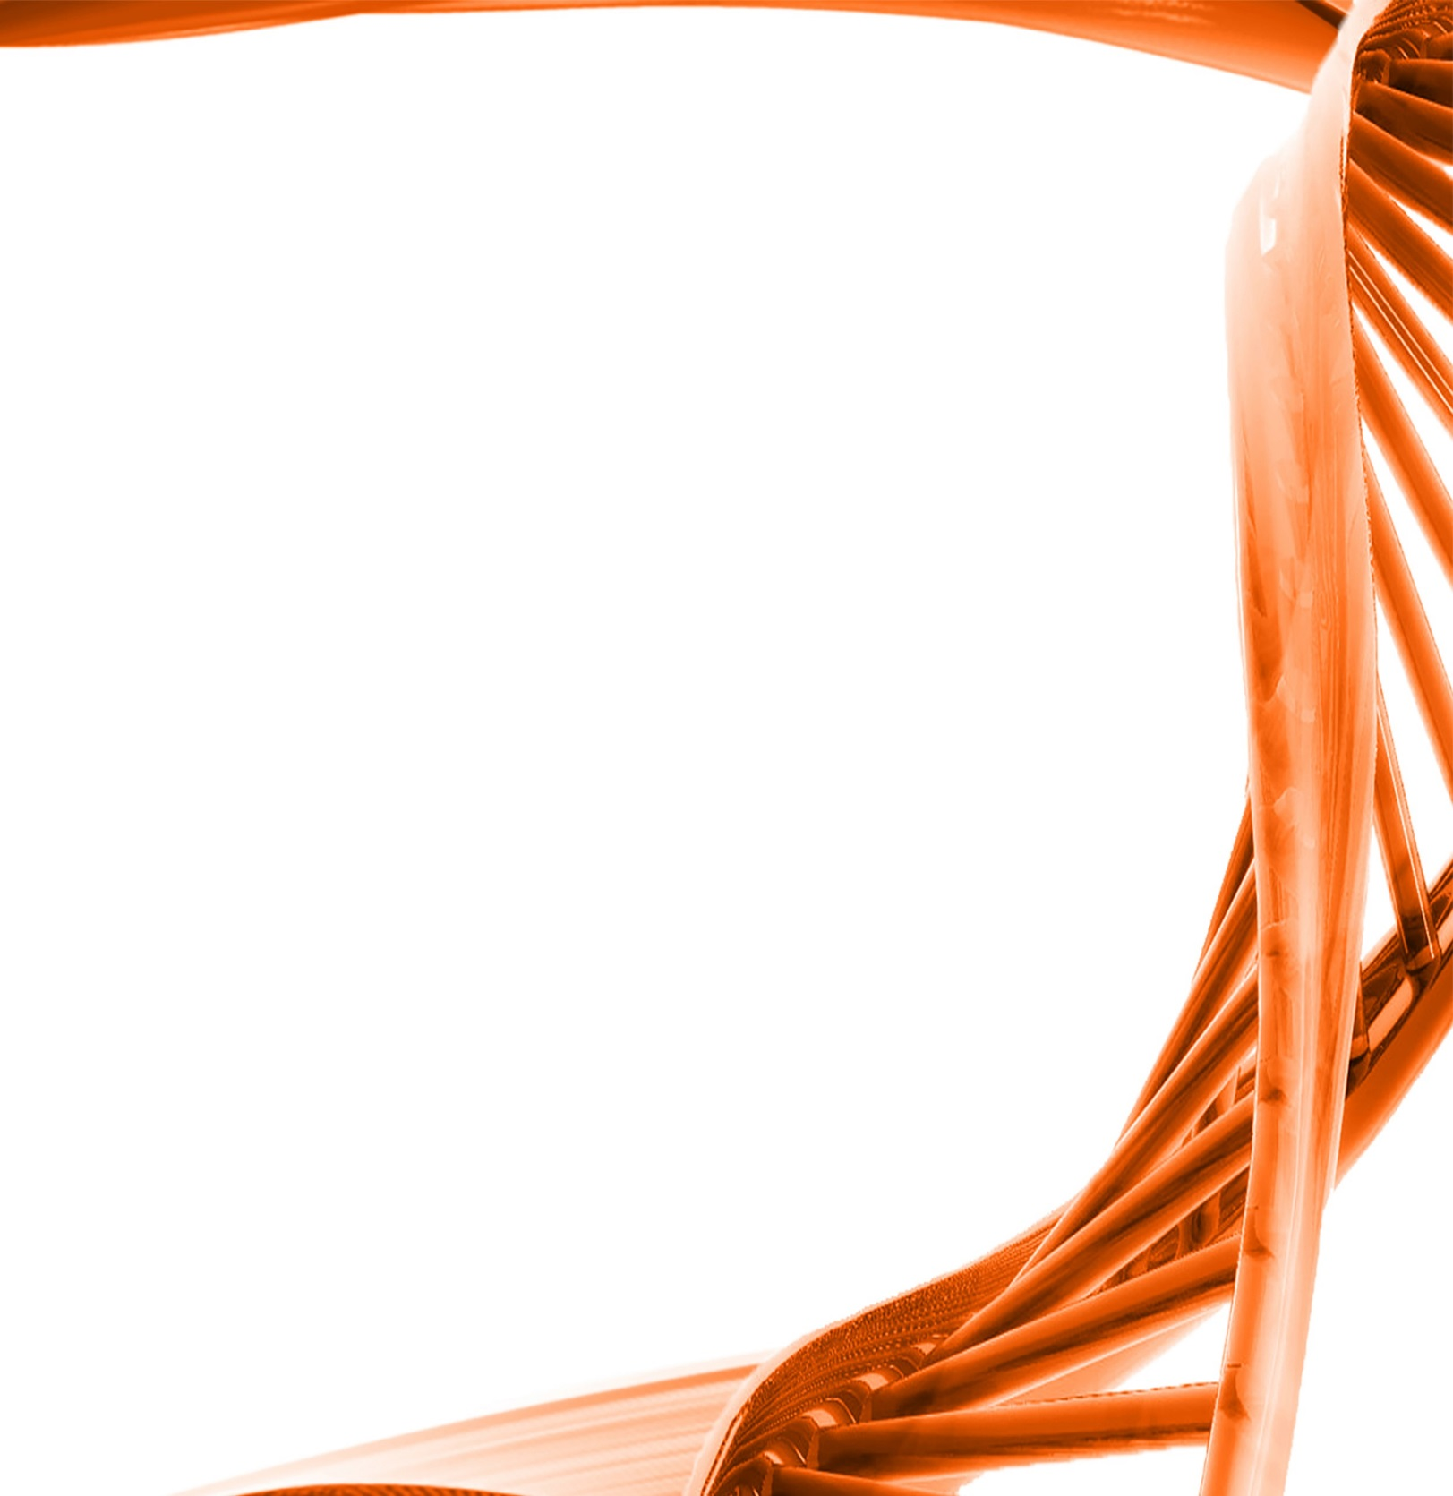

MICROBIOLOGY & MOLECULAR GENETICS
SEMINAR

Students seminar
Ibrahim Farag “Exploring the ecological and metabolic diversities in Candidate Phylum “Latescibacteria” (WS3)”
Jorge Lightfoot “Metabolically Engineering Aspergillus nidulans using RNA interference”

Monday
February 6th, 2017
3:30pm
RM LSE 215

