MICROBIOLOGY & MOLECULAR GENETICS
SEMINAR
“Lipid homeostasis during Salmonella bacteremia”
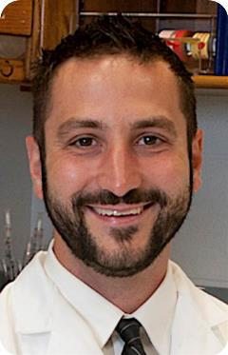
Zachary D. Dalebroux, Ph.D.
Health Sciences Center
University of Oklahoma
Monday
January 22, 2017
3:30pm
RM LSE 215

