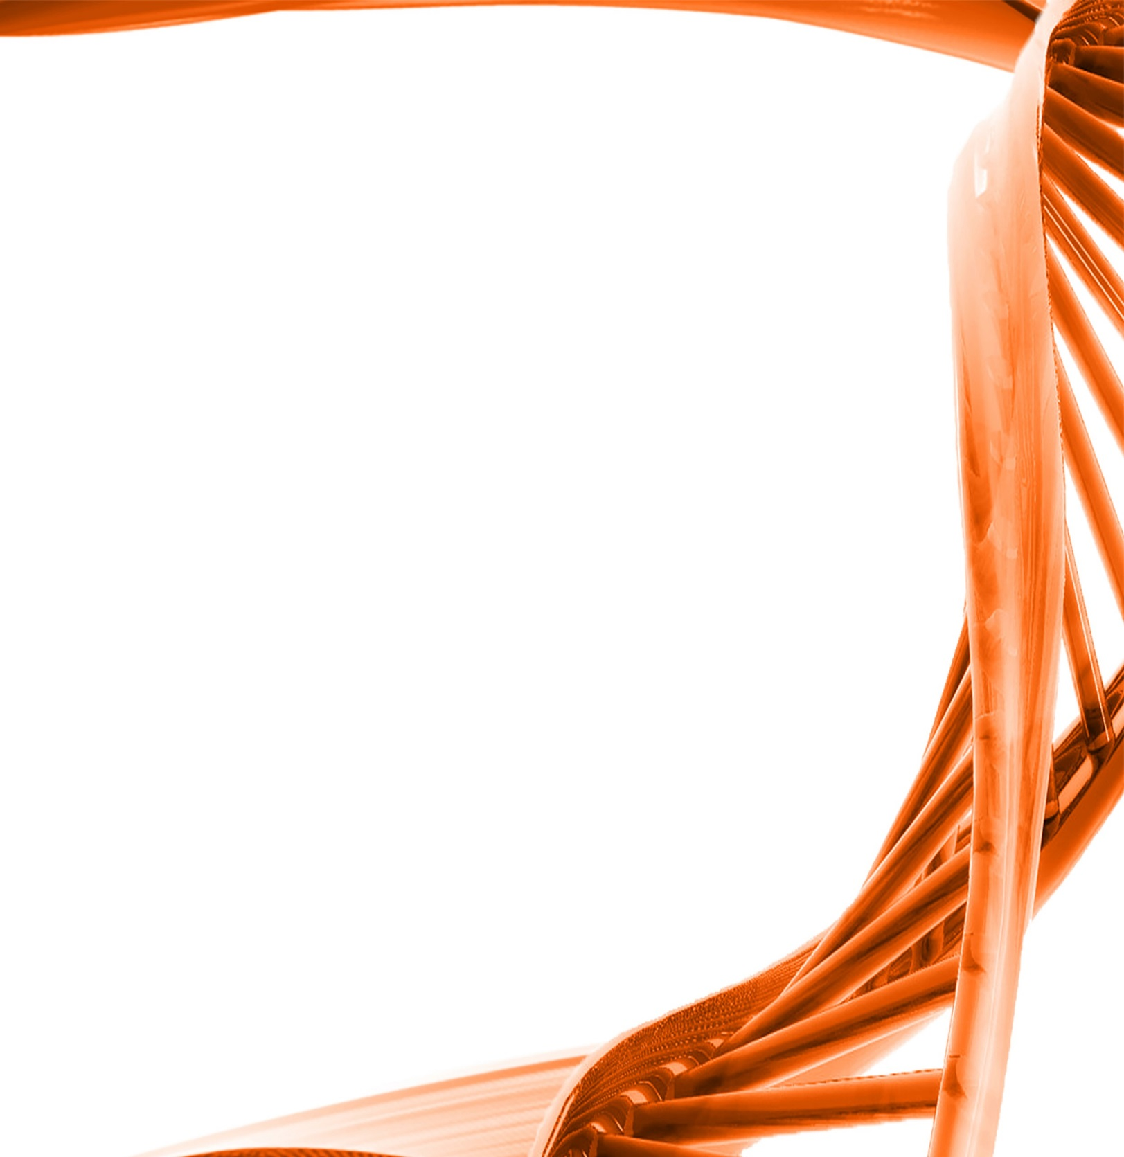
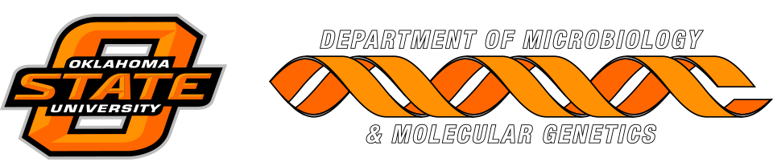

MICROBIOLOGY & MOLECULAR GENETICS
Departmental Journal Club
MICR 6120

Monday
August 29th, 2016
11:30am-12:20pm
RM 122 Classroom Bldg.

Presented by
Shelby Calkins
PHD Student

Title: A new small molecule inhibits Streptococcus mutans biofilms in vitro and in vivo
Authors: W. Pan1, M. Fan1, H. Wu2, C. Melander3 and C. Liu1

Abstract: Aims: The aim of this study was to identify new small molecules that can inhibit Streptococcus mutans biofilms by in vitro and in vivo model.
Methods and Results: We evaluated the effect of a small molecule 2-amino- imidazole/triazole conjugate (2-AI/T) on the formation of Strep. mutans biofilms by culturing in 96-well plates. Toxicity was assessed through cell culture and intragastrically administering to mice. The anti-biofilm and anti- caries effects were investigated in vivo. The inhibitive mechanism was detected by isobaric tag for relative and absolute quantification (itraq) and RT-QPCR. In vitro and in vivo study revealed that 2-AI/T significantly inhibited biofilm formation of Strep. mutans and is more so than inhibiting planktonic cells without toxicity. The ribosome and histidine metabolism pathways of Strep. mutans were significantly regulated by this compound. Conclusions: These results suggest that the 2-AI/T conjugate is a potent inhibitor that can be potentially developed into a new drug to treat and prevent dental caries.
Significance and Impact of the Study: This is the first study to use small molecule from marine natural products, to protect from dental caries in vivo. It has potential broad range application in clinical caries prevention, or as a bioactive ingredient for food applications.

