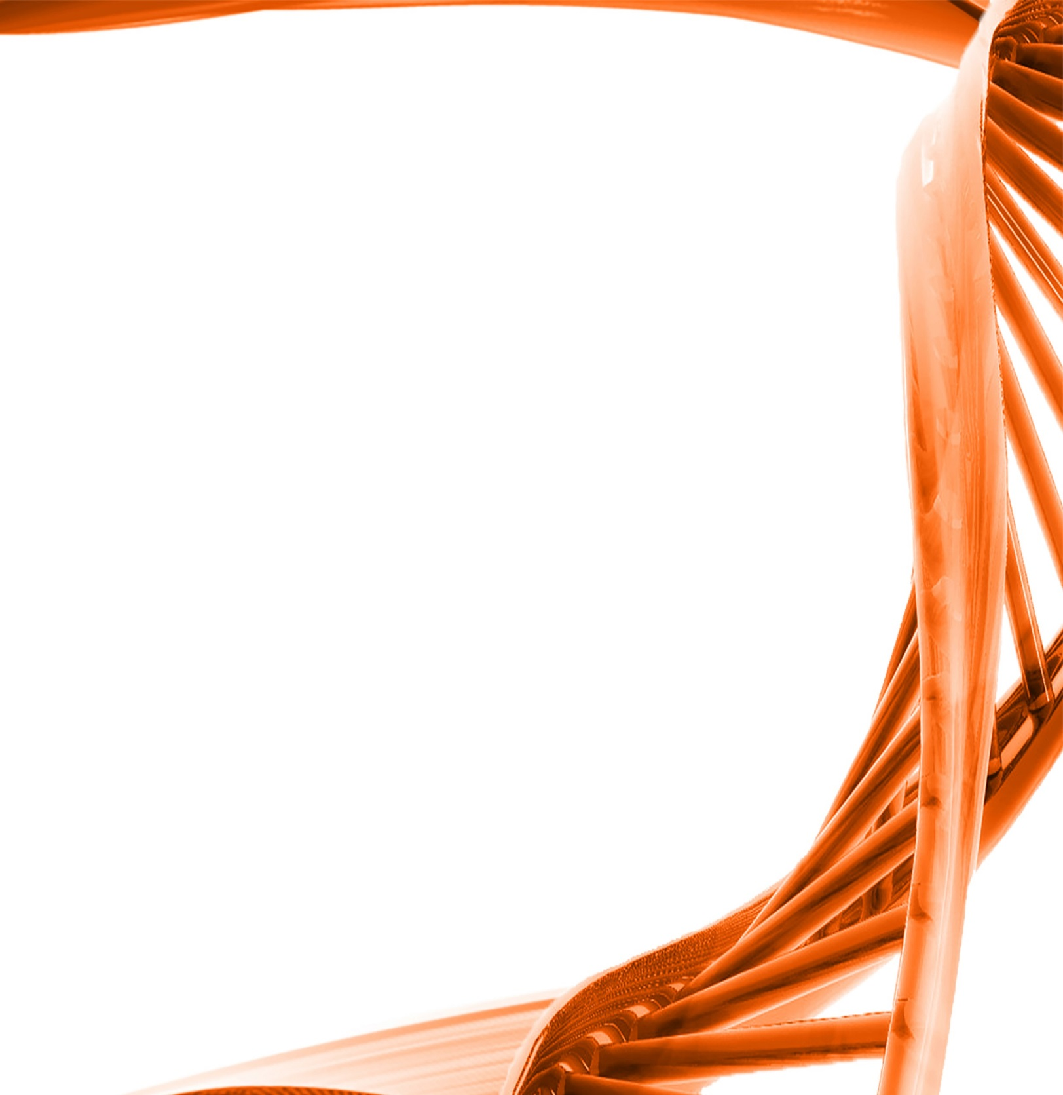

MICROBIOLOGY & MOLECULAR GENETICS
Departmental Journal Club
MICR 6120

Monday
October 31st, 2016
11:30am-12:20pm
RM 122 Classroom Bldg.

Presented by
Radwa Hanafy
PHD Student

Title: Surveying the endomicrobiome and ectomicrobiome of bark beetles: The case of Dendroctonus simplex

Authors: Audrey-Anne Durand, Amélie Bergeron, Philippe Constant, Jean-Philippe Buffet, Eric Déziel
& Claude Guertin
Many bark beetles belonging to the Dendroctonus genus carry bacterial and fungal microbiota, forming a symbiotic complex that helps the insect to colonize the subcortical environment of the host tree. However, the biodiversity of those bacteria at the surface of the cuticle or inside the body parts of bark beetles is not well established. The aim of this study was to characterize the bacterial microbiome associated with the eastern larch beetle, Dendroctonus simplex, using bacterial 16S rRNA gene pyrosequencing. The ecto- and endomicrobiome and the subcortical galleries were investigated. Several bacterial genera were identified, among which Pseudomonas, Serratia and Yersinia are associated with the surface of the beetle cuticle, and genera belonging to Enterobacteriaceae and Gammaproteobacteria with the interior of the insect body. The index of dissimilarity indicates that the bacterial microbiome associated with each environment constitutes exclusive groups. These results suggest the presence of distinct bacterial microbiota on the surface of the cuticle and the interior of D. simplex body. Additionally, the bacterial diversity identified in the galleries is substantially different from the ectomicrobiome, which could indicate a selection by the insect. This study reports for the first time the identification of the eastern larch beetle microbiome.

