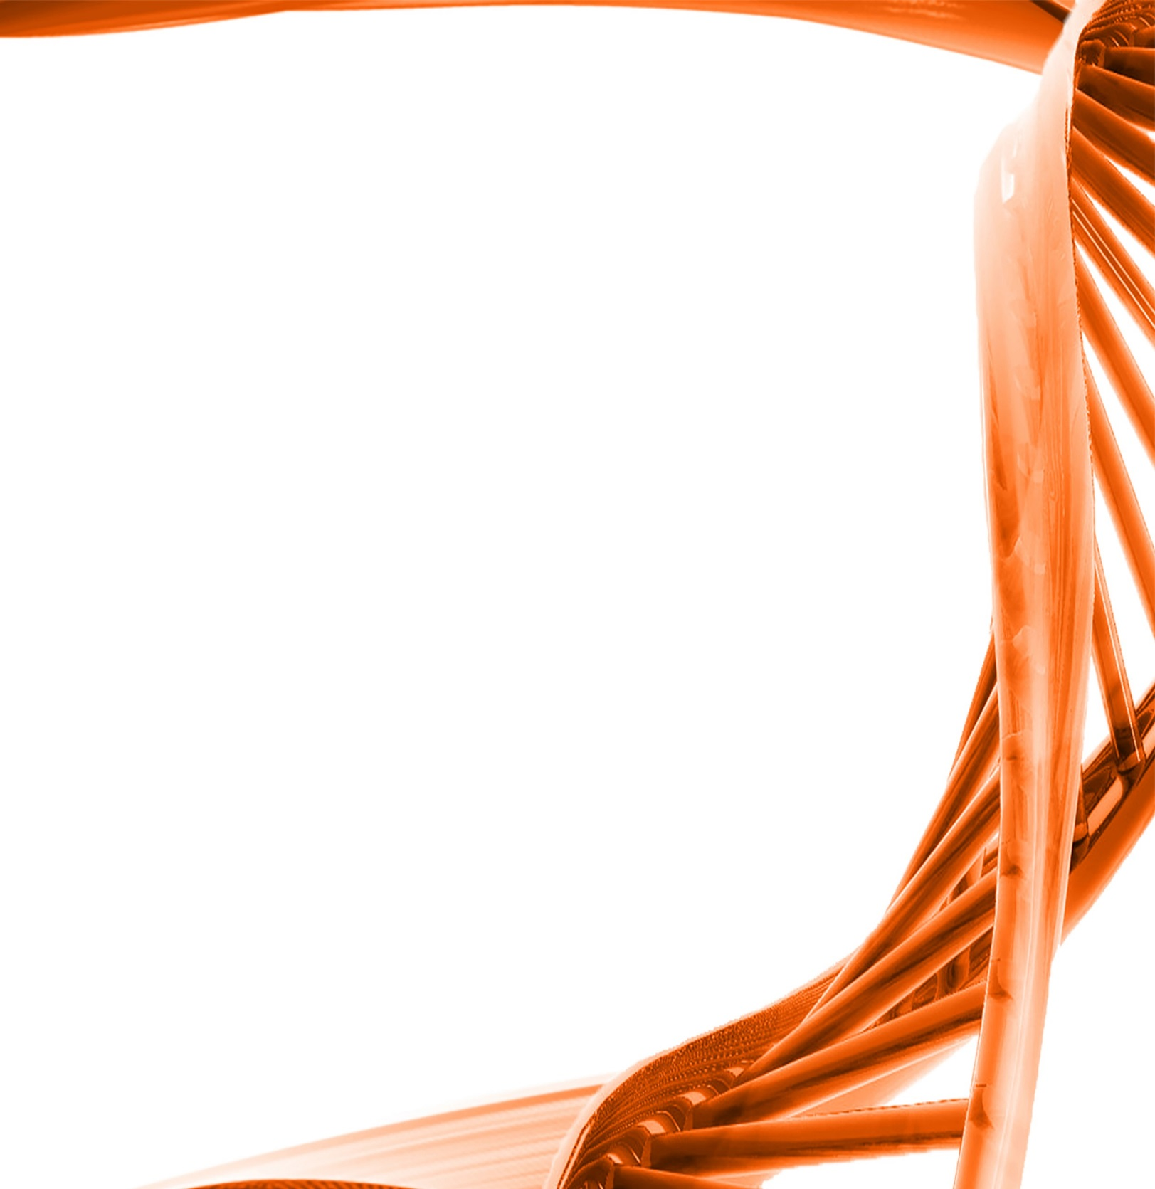

MICROBIOLOGY & MOLECULAR GENETICS
Departmental Journal Club
MICR 6120

Monday
November 14th, 2016
11:30am-12:20pm
RM 122 Classroom Bldg.

Presented by
Vivek Patel
Accelerated Masters Student

Title: Alanine metabolism is essential for growth and biofilm formation of Streptococcus mutans
Authors: W. Qiu, X. Zheng, Y. Wei1, X. Zhou, K. Zhang, S. Wang, L. Cheng,Y. Li, B. Ren,
X. Xu1, Y. Li1 and M. Li1
Part of the D-alanine (D-Ala) metabolic pathway in bacteria involves the conversion of L-alanine to DAla by alanine racemase and the formation of Dalanyl–D-alanine by D-alanine–D-alanine ligase, the product of which is involved in cell wall peptidoglycan synthesis. At present, drugs that target the metabolic pathway of D-Ala are already in clinical use – e.g. D-cycloserine (DCS) is used as an antibiotic against Mycobacterium tuberculosis. Streptococcus mutans is the main cariogenic bacterium in the oral cavity. Its D-Ala metabolismassociated enzymes alanine racemase and D-alanine–D-alanine ligase are encoded by the genes smu.1834 and smu.599, respectively, which may be potential targets for inhibitors. In this study, the addition of DCS blocked the D-Ala metabolic pathway in S. mutans, leading to bacterial cell wall defects, significant inhibition of bacterial growth and biofilm formation, and reductions in extracellular polysaccharide production and bacterial adhesion. However, the exogenous addition of D-Ala could reverse the inhibitory effect of DCS. Through the means of drug regulation, our study demonstrated, for the first time, the importance of D-Ala metabolism in the survival and biofilm formation of S. mutans. If the growth of S. mutans can be specifically inhibited by designing drugs that target D-Ala metabolism, then this may serve as a potential new treatment for dental caries.

