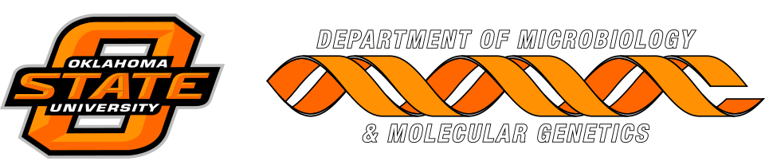

MICROBIOLOGY & MOLECULAR GENETICS
SEMINAR
“Organismal interdependencies as evolutionary drivers in the anaerobic world”
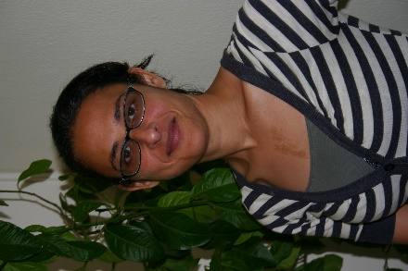
Noha Youssef
Professor
OSU - MMG
Monday
November 20, 2017
3:30pm
RM LSE 215

