MICROBIOLOGY & MOLECULAR GENETICS
SEMINAR
“Uncovering new treatment strategies for P. aeruginosa wound infections”
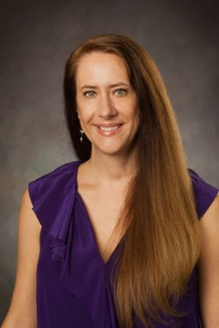
Kendra Rumbaugh
Professor
Dept. of Surgery
TX Tech Health Sciences Center
Monday
November 13, 2017
3:30pm
RM LSE 215

