MICROBIOLOGY & MOLECULAR GENETICS
SEMINAR
“Insights into candidate microbial phyla inhabiting geothermal springs”
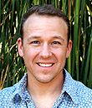
Brian Hedlund
Professor
School of Life Sciences
UNLV
Monday
November 6, 2017
3:30pm
RM LSE 215

