MICROBIOLOGY & MOLECULAR GENETICS
SEMINAR
Prakash Sah
PhD student, MMG
“CT226-Protein flightless1 homologue interaction in Chlamydia trachomatis infection”
Radwa Hanafy
PhD student, MMG
“Exploring the diversity of Anaerobic Gut Fungi (AGF) in different herbivores”
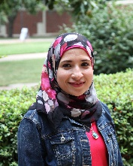
Monday
October 30 2017
3:30pm
RM LSE 215

