MICROBIOLOGY & MOLECULAR GENETICS
SEMINAR
“Initiation of cell fission in E. coli.”
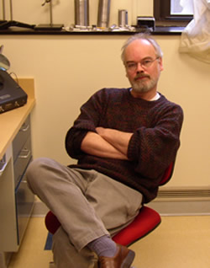
Piet de Boer
Professor
School of Medicine
Case Western Reserve University
Monday
October 09 2017
3:30pm
RM LSE 215

