OKLAHOMA STATE UNIVERSITY
SPONSORED BY
MICROBIOLOGY & MOLECULAR GENETICS

Jason Kirksey, PhD
OSU- Vice President for Institutional Diversity

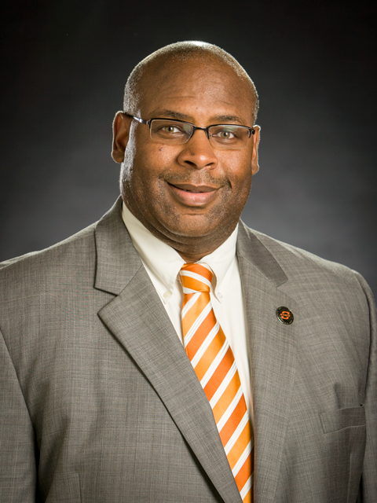

“Understanding Diversity”

MONDAY
AUGUST 28, 2017
215 Life Science East
3:30 - 4:30pm

