MICROBIOLOGY & MOLECULAR GENETICS
SEMINAR
“Characterization of Proteins in the Type IV B
Secretion System of Coxiella burnetii”
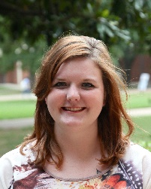
Melissa Brewer
“Investigating the coupling of CO₂ hydration, proton pumping, and cyclic electron transport by specialized NDH-1 complexes in cyanobacteria”
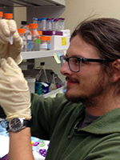
Neil Miller
Monday
April 23, 2018
3:30pm | RM LSE 215

