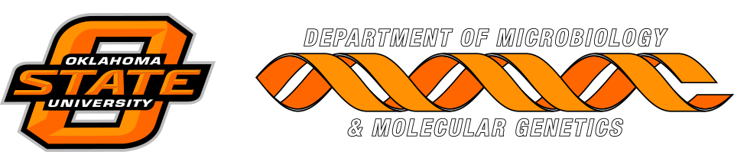

MICROBIOLOGY & MOLECULAR GENETICS
SEMINAR
“Oxidative extracellular electron transfer -
rethinking the role of microbes in biogeochemical cycles”
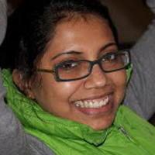
Arpita Bose, PhD
Dept of Biology
Washington University in St. Louis
Monday
March 26, 2018
3:30pm
RM LSE 215

