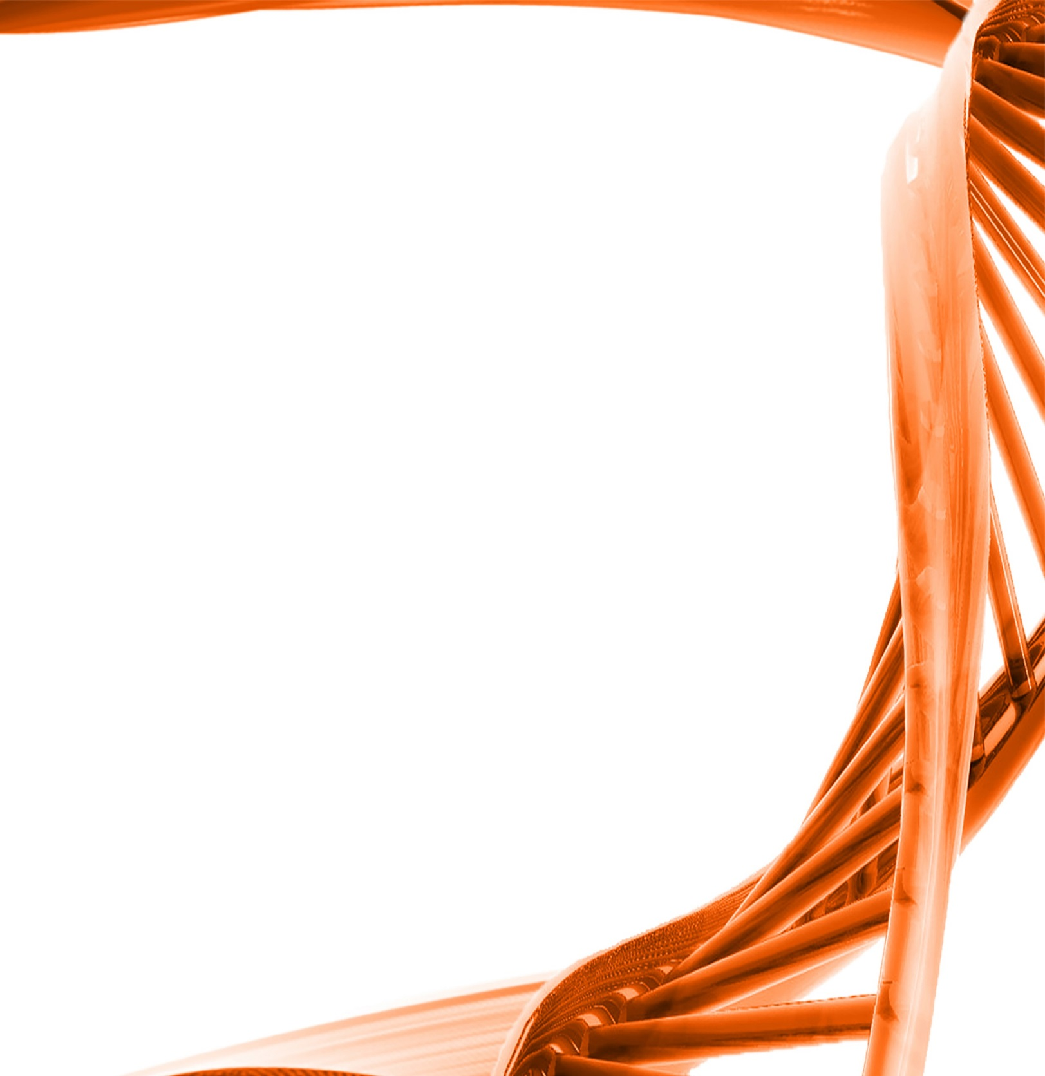
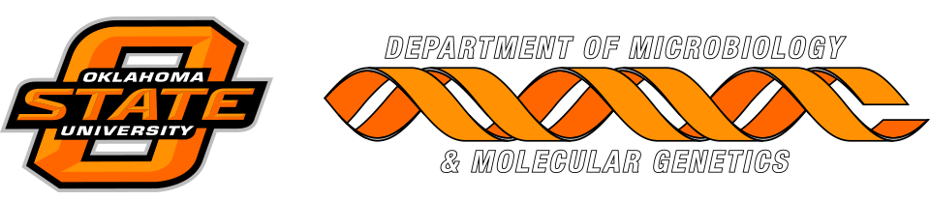

MICROBIOLOGY & MOLECULAR GENETICS
SEMINAR

Students seminar
Rawan Eleshy “Staphylococcus aureus: Antibiotic Resistance & Internalization into Host Mammalian Cells”
Sharmily Khanam “Calcium-regulated antibiotic resistance in the human pathogen pseudomonas aeruginosa”

Monday
March 20th, 2017
3:30pm
RM LSE 215

