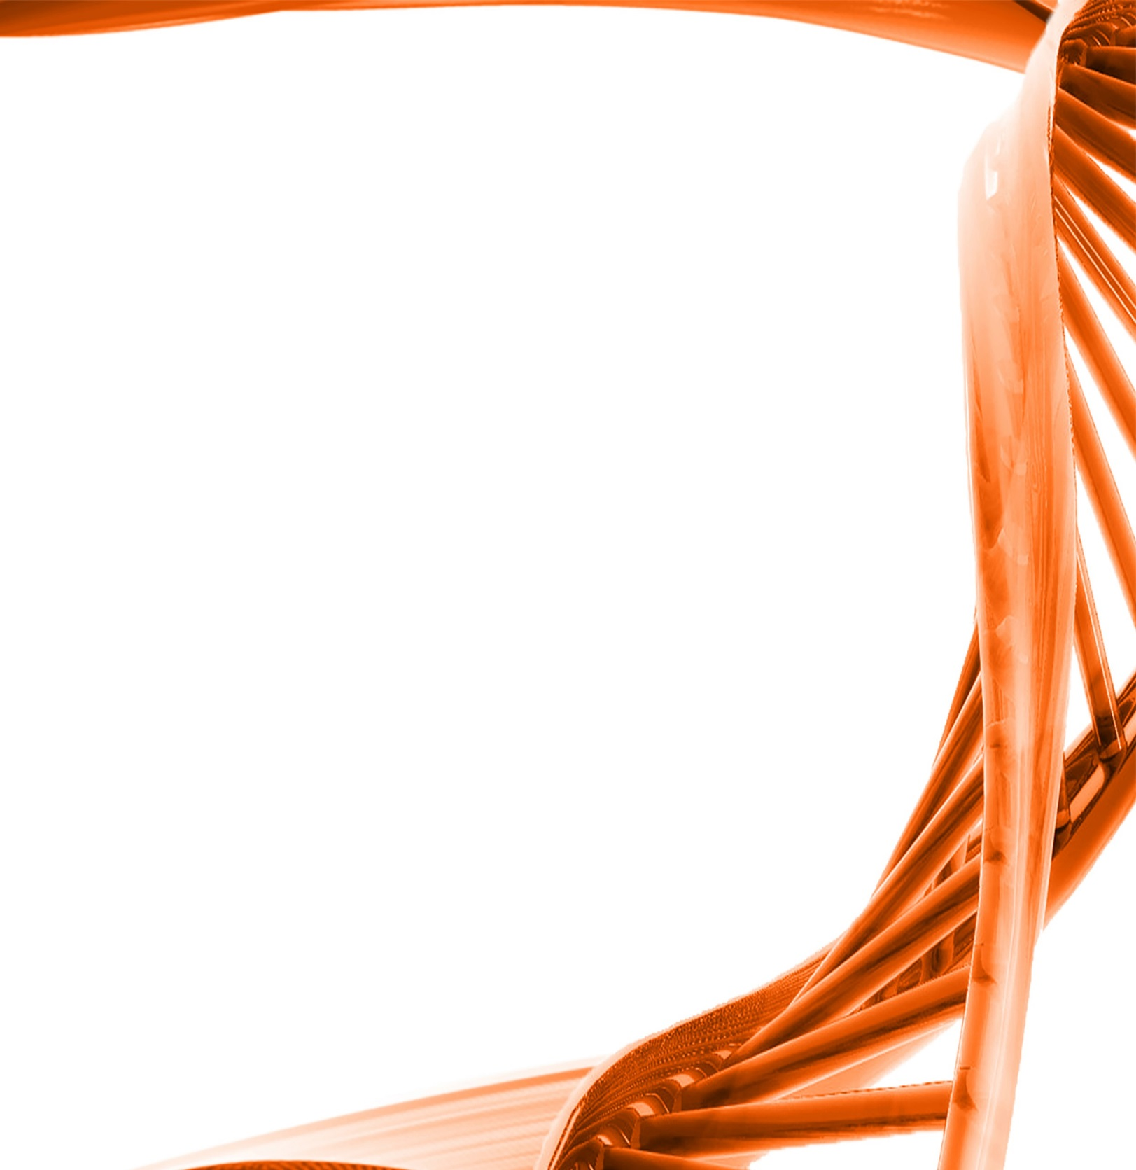
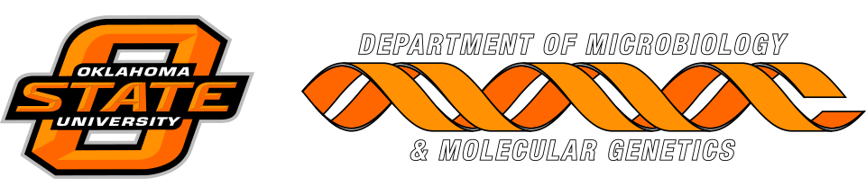

MICROBIOLOGY & MOLECULAR GENETICS
SEMINAR

“Microbially-mediated nitrogen cycling: a
geological perspective”

Dr. Tracy Quan
Associate Professor
Boone Pickens School of Geology
Oklahoma State University
Monday
March 6th, 2017
3:30pm
RM LSE 215

