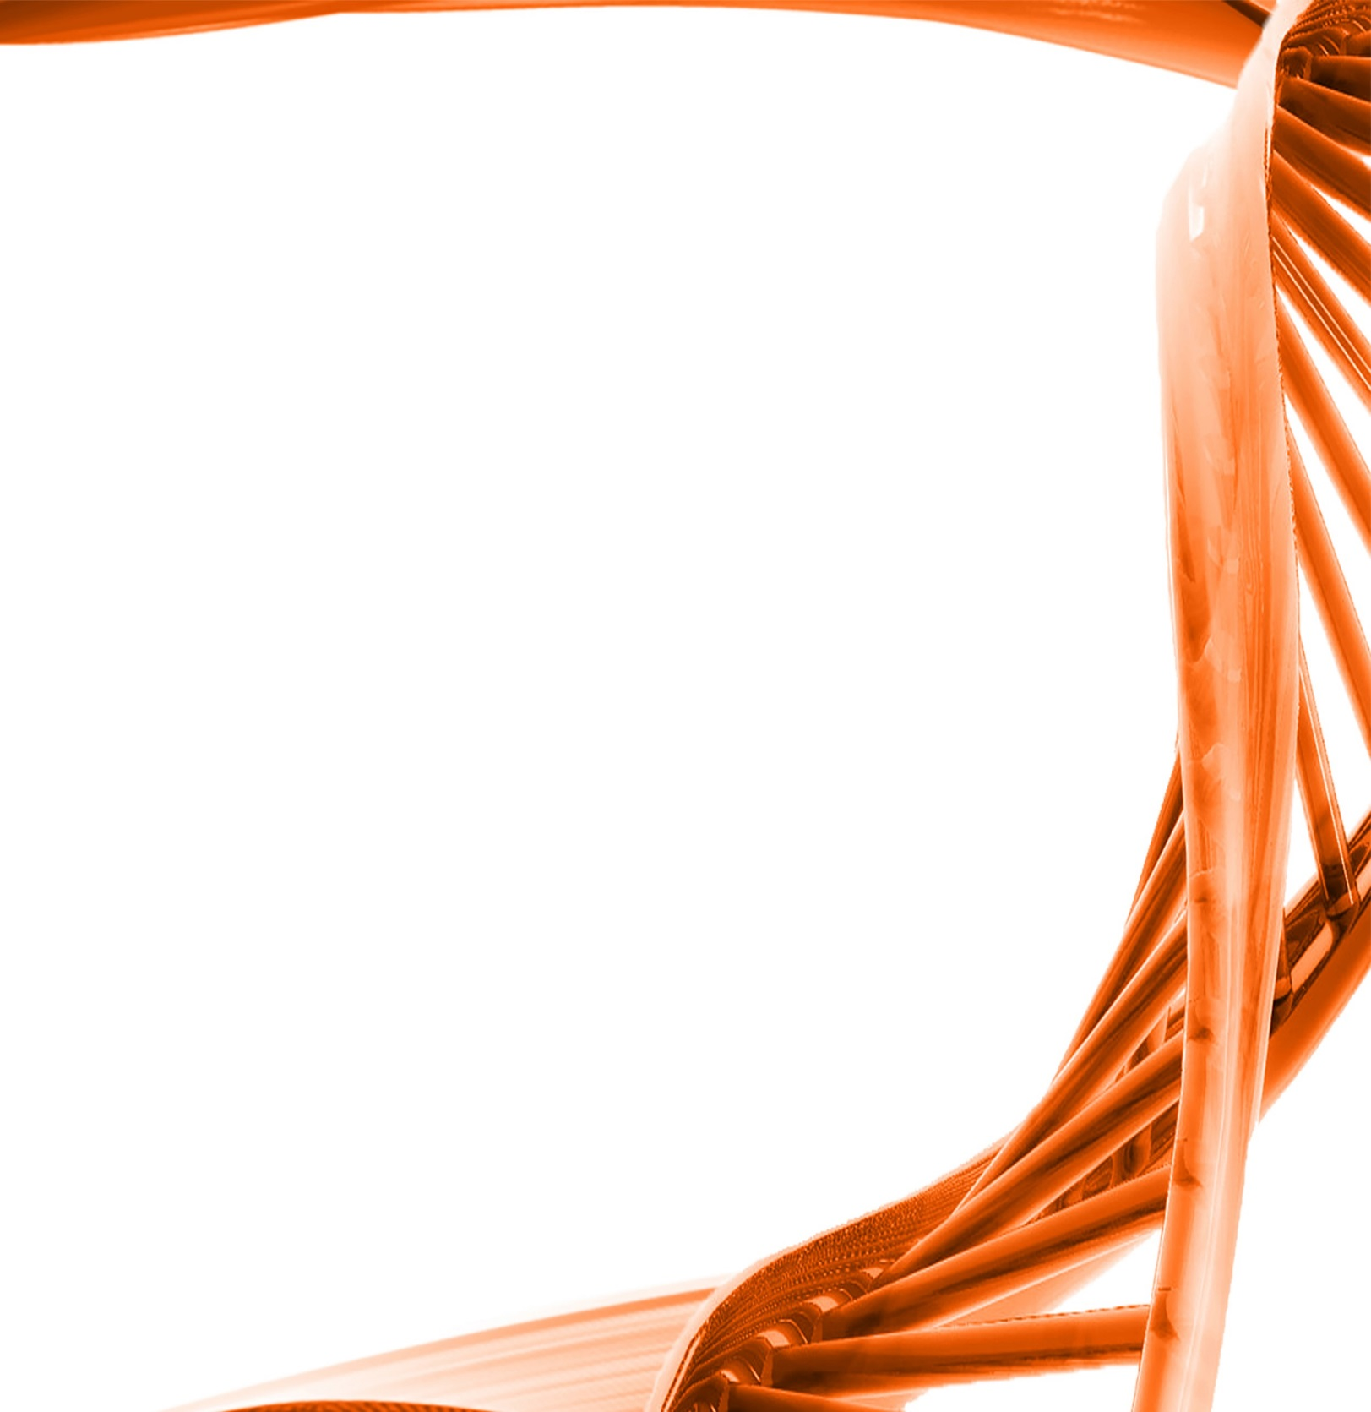

MICROBIOLOGY & MOLECULAR GENETICS
SEMINAR

“Harnessing mycorrhizal fungi for grassland restoration and sustainable agriculture”

Dr. Gail Wilson

Sarkeys Distinguished Professor
Department of Natural Resource Ecology and Management
Monday
February 27th, 2017
3:30pm
RM LSE 215

