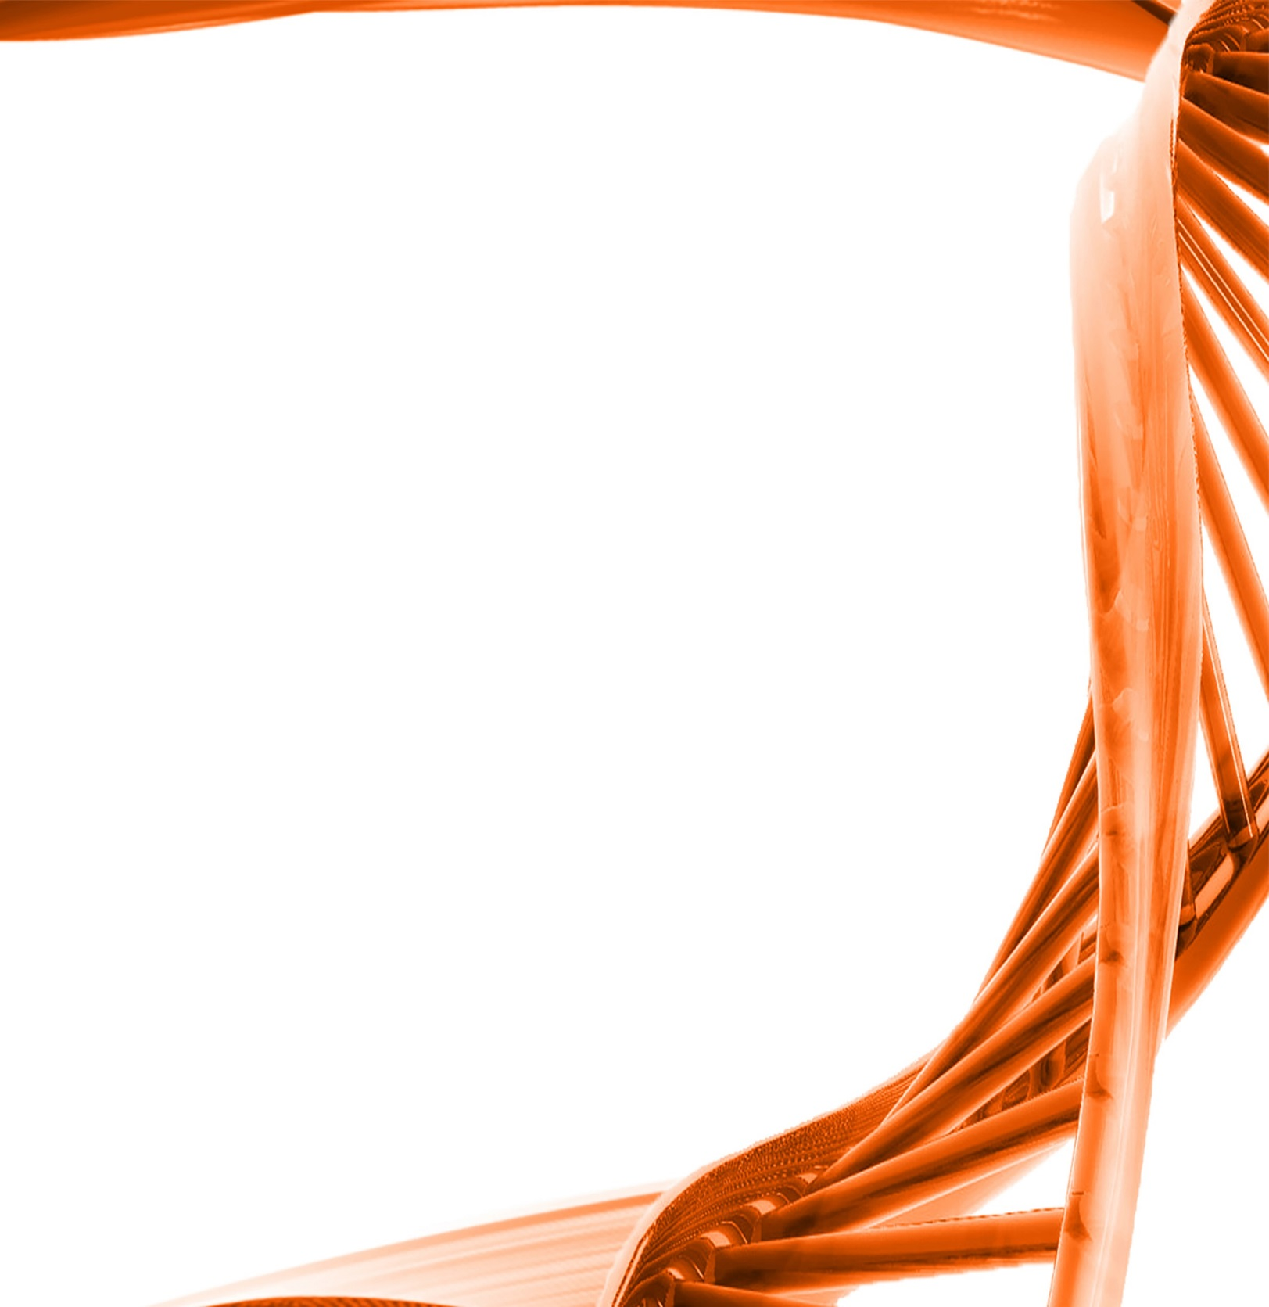

MICROBIOLOGY & MOLECULAR GENETICS
SEMINAR

“Fly microbiome”

Dr. Justin Talley
Associate Professor
Entymology and Plant pathology
Oklahoma State University

Monday
February 13th, 2017
3:30pm
RM LSE 215

