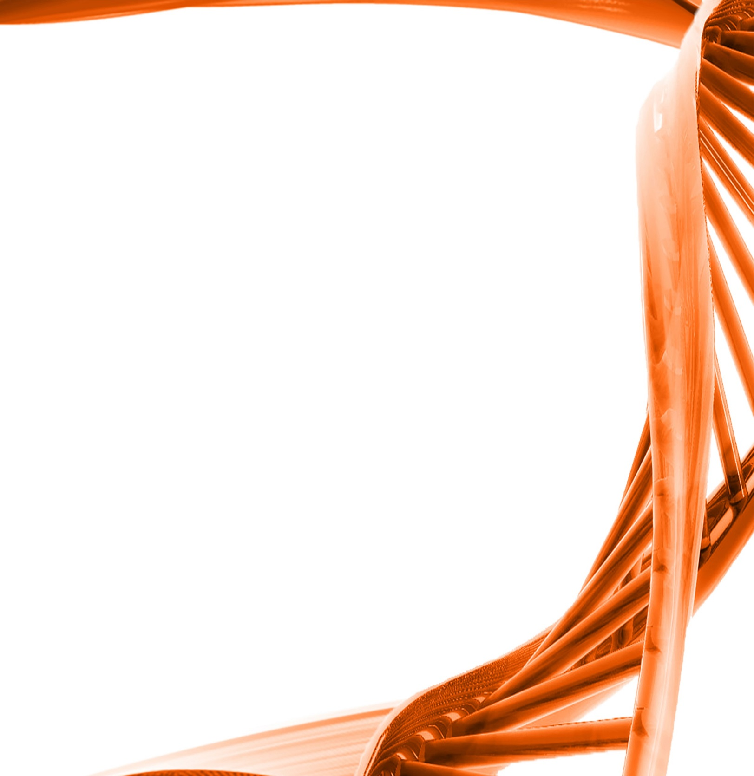

MICROBIOLOGY & MOLECULAR GENETICS
Departmental Journal Club
MICR 6120

Monday
October 24th, 2016
11:30am-12:20pm
RM 122 Classroom Bldg.

Presented by
Prakash Sah
PHD Student

Title: The type III secretion system apparatus determines the intracellular niche of bacterial pathogens

Authors: Juan Dua, Analise Z. Reevesa, Jessica A. Kleinc, Donna J. Twedtc, Leigh A. Knodlerc, and Cammie F. Lessera
Upon entry into host cells, intracellular bacterial pathogens establisha variety of replicative niches. Although some remodel phagosomes, others rapidly escape into the cytosol of infected cells. Little is currently known regarding how professional intracytoplasmic pathogens, including Shigella, mediate phagosomal escape. Shigella, likemany other Gram-negative bacterial pathogens, uses a type III secretion system to deliver multiple proteins, referred to as effectors, into host cells. Here, using an innovative reductionist-based approach,we demonstrate that the introduction of a functional Shigella type III secretion system, but none of its effectors, into a laboratory strain of Escherichia coli is sufficient to promote the efficient vacuole lysis and escape of the modified bacteria into the cytosol of epithelial cells. This establishes for the first time, to our knowledge, a direct physiologic role for the Shigella type III secretion apparatus (T3SA) in mediating phagosomal escape. Furthermore, although protein components of the T3SA share a moderate degree of structural and functional conservation across bacterial species, we show that vacuole lysis is not a common feature of T3SA, as an effectorless strain of Yersinia remains confined to phagosomes. Additionally, by exploiting the functiona lnterchangeability of the translocator components of the T3SA of Shigella, Salmonella, and Chromobacterium, we demonstrate that a single protein component of the T3SA translocon—Shigella IpaC, Salmonella SipC, or Chromobacterium CipC—determines the fat of intracellular pathogens within both epithelial cells and macro-phages. Thus, these findings have identified a likely paradigm by which the replicative niche of many intracellular bacterial patho-gens is established.

