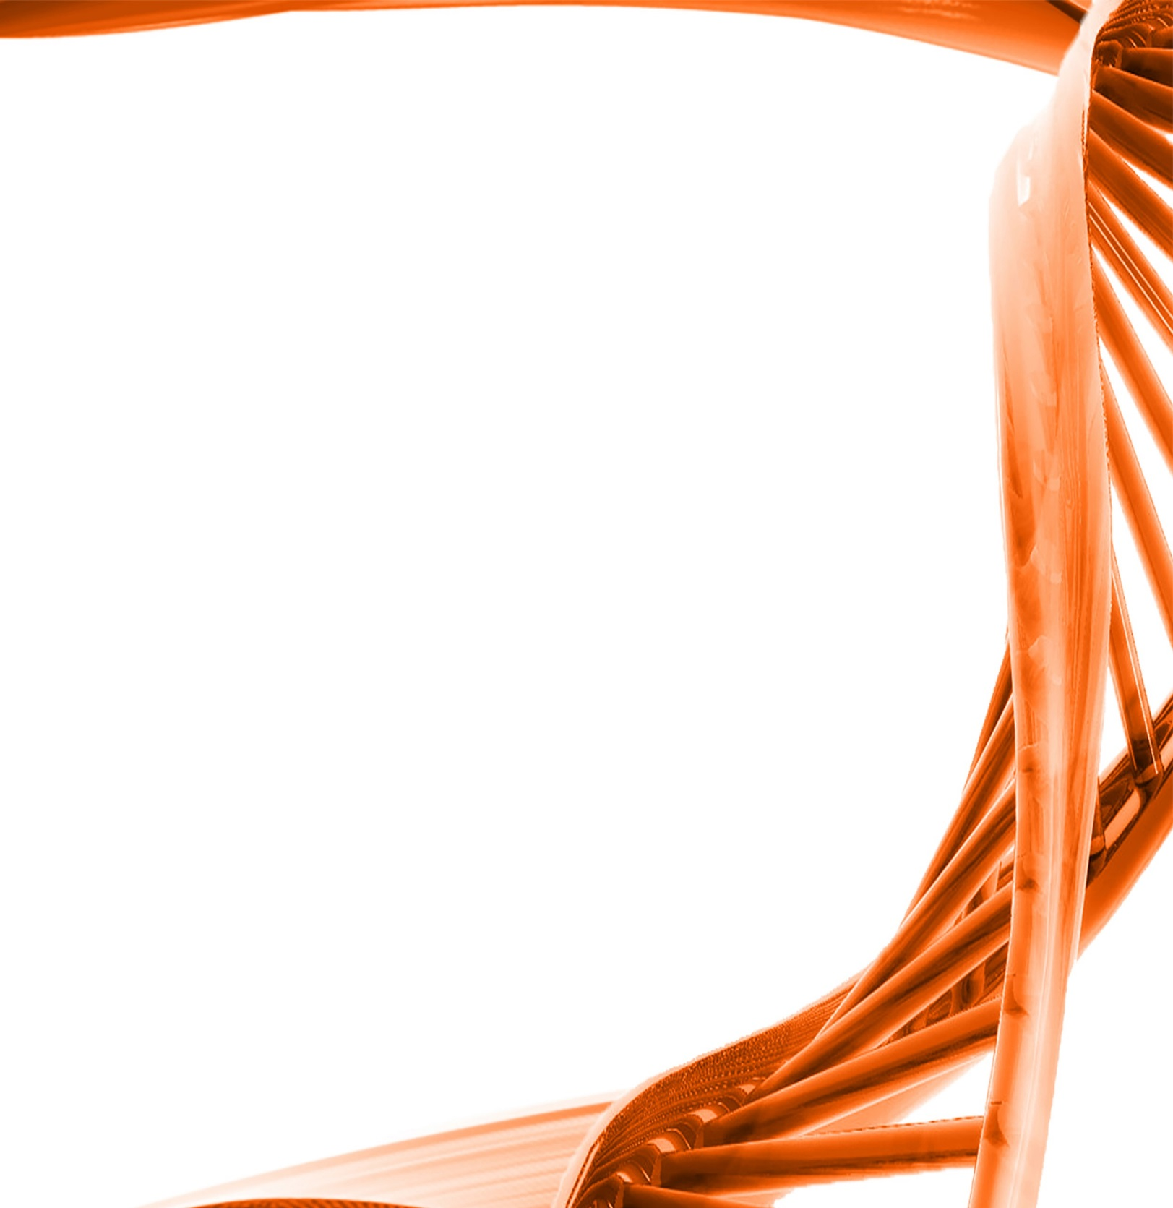
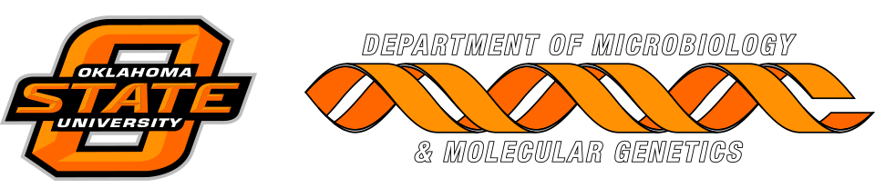

MICROBIOLOGY & MOLECULAR GENETICS
Departmental Journal Club
MICR 6120

Monday
September 26th, 2016
11:30am-12:20pm
RM 122 Classroom Bldg.

Presented by
Ibrahim Farag
PHD Student

Title: Complete nitrification by Nitrospira bacteria

Authors: Holger Daims, Elena V. Lebedeva, Petra Pjevac, Ping Han, Craig Herbold, Mads Albertsen, Nico Jehmlich, Marton Palatinszky, Julia Vierheilig, Alexandr Bulaev, Rasmus H. Kirkegaard, Martin von Bergen, Thomas Rattei, Bernd Bendinger, Per H. Nielsen, & Michael Wagner
Nitrification, the oxidation of ammonia via nitrite to nitrate, has always been considered to be a two-step process catalyzed by chemolithoautotrophic microorganisms oxidizing either ammonia or nitrite. No known nitrifier carries out both steps, although complete nitrification should be energetically advantageous. This functional separation has puzzled microbiologists for a century. Here we report on the discovery and cultivation of a completely nitrifying bacterium from the genus Nitrospira, a globally distributed group of nitrite oxidizers. The genome of this chemolithoautotrophic organism encodes the pathways both for ammonia and nitrite oxidation, which are concomitantly expressed during growth by ammonia oxidation to nitrate. Genes affiliated with the phylogenetically distinct ammonia monooxygenase and hydroxylamine dehydrogenase genes of Nitrospira are present in many environments and were retrieved on Nitrospiracontigs in new metagenomes from engineered systems. These findings fundamentally change our picture of nitrification and point to completely nitrifying Nitrospira as key components of nitrogen-cycling microbial communities.

