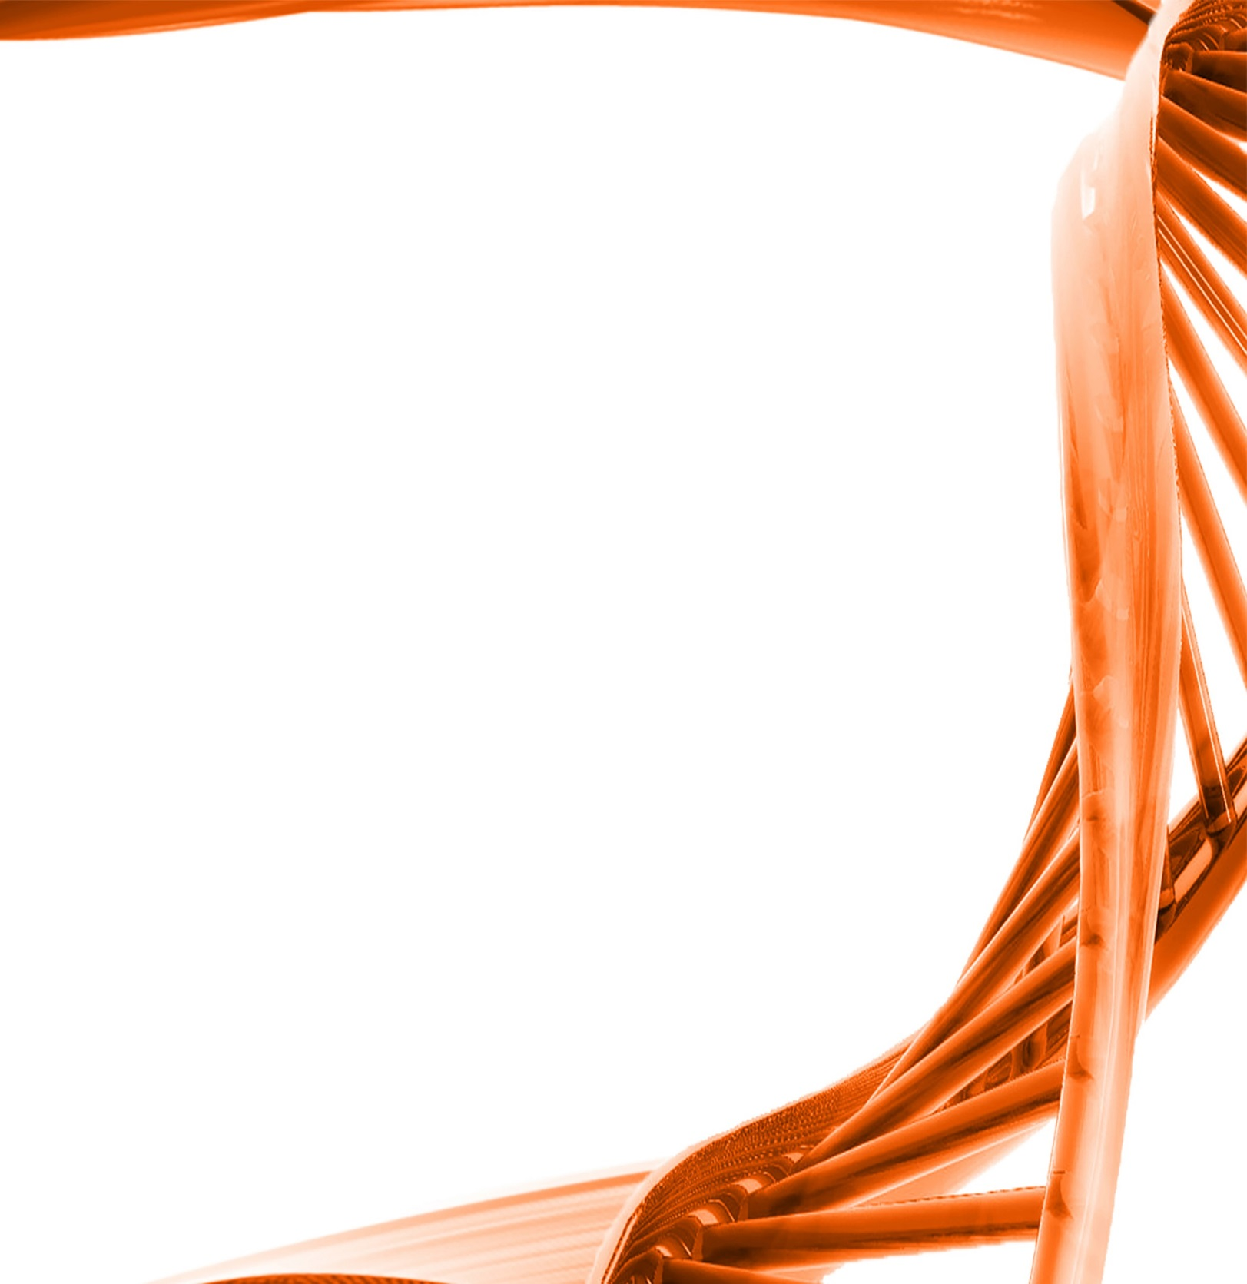

MICROBIOLOGY & MOLECULAR GENETICS
Departmental Journal Club
MICR 6120

Monday
September 26th, 2016
11:30am-12:20pm
RM 122 Classroom Bldg.

Presented by
Breeanna Russ
Accelerated Master’s Student

Title: Neisseria gonorrhoeae Crippled Its Peptidoglycan Fragment Permease To Facilitate Toxic Peptidoglycan Monomer Release
Authors: Jia Mun Chan and and Joseph P. Dillard
Neisseria gonorrhoeae (gonococci) and Neisseria meningitidis (meningococci) are human pathogens that cause gonorrhea and meningococcal meningitis, respectively. Both N. gonorrhoeae and N. meningitidis release a number of small peptidoglycan (PG) fragments, including proinflammatory PG monomers, although N. meningitidis releases fewer PG monomers. The PG fragments released by N. gonorrhoeae and N. meningitidis are generated in the periplasm during cell wall remodeling, and a majority of these fragments are transported into the cytoplasm by an inner membrane permease, AmpG; however, a portion of the PG fragments are released into the extracellular environment through unknown mechanisms. We previously reported that the expression of meningococcal ampG in N. gonorrhoeae reduced PG monomer release by gonococci. This finding suggested that the efficiency of AmpG-mediated PG fragment recycling regulates the amount of PG fragments released into the extracellular milieu. We determined that three AmpG residues near the Cterminal end of the protein modulate AmpG's efficiency. We also investigated the association between PG fragment recycling and release in two species of humanassociated nonpathogenic Neisseria: N. sicca and N. mucosa. Both N. sicca and N. mucosa release lower levels of PG fragments and are more efficient at recycling PG fragments than N. gonorrhoeae. Our results suggest that N. gonorrhoeae has evolved to increase the amounts of toxic PG fragments released by reducing its PG recycling efficiency.

