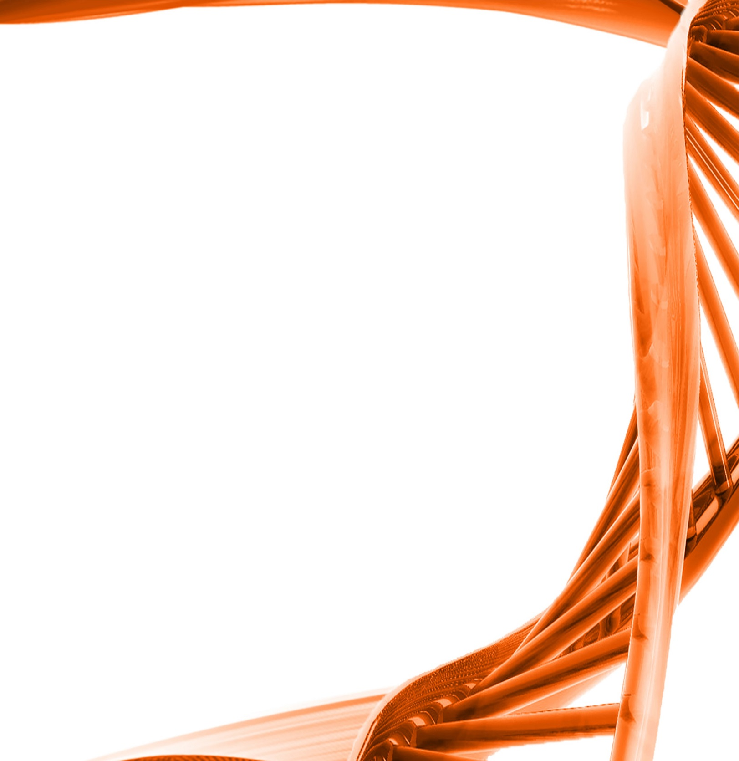

MICROBIOLOGY & MOLECULAR GENETICS
Departmental Journal Club
MICR 6120

Monday
October 3rd, 2016
11:30am-12:20pm
RM 122 Classroom Bldg.

Presented by
Neil Miller
PHD Student

Title: Terminal acidic shock inhibits sour beer bottle conditioning by Saccharomyces cerevisiae

Authors: Cody M. Rogers , Devon Veatch , Adam Covey , Caleb Staton, Matthew L. Bochman
During beer fermentation, the brewer's yeast Saccharomyces cerevisiae experiences a variety of shifting growth conditions, culminating in a low-oxygen, low-nutrient, high-ethanol, acidic environment. In beers that are bottle conditioned (i.e., carbonated in the bottle by supplying yeast with a small amount of sugar to metabolize into CO2), the S. cerevisiae cells must overcome these stressors to perform the ultimate act in beer production. However, medium shock caused by any of these variables can slow, stall, or even kill the yeast, resulting in production delays and economic losses. Here, we describe a medium shock caused by high lactic acid levels in an American sour beer, which we refer to as “terminal acidic shock”. Yeast exposed to this shock failed to bottle condition the beer, though they remained viable. The effects of low pH/high [lactic acid] conditions on the growth of six different brewing strains of S. cerevisiae were characterized, and we developed a method to adapt the yeast to growth in acidic beer, enabling proper bottle conditioning. Our findings will aid in the production of sour-style beers, a trending category in the American craft beer scene.

