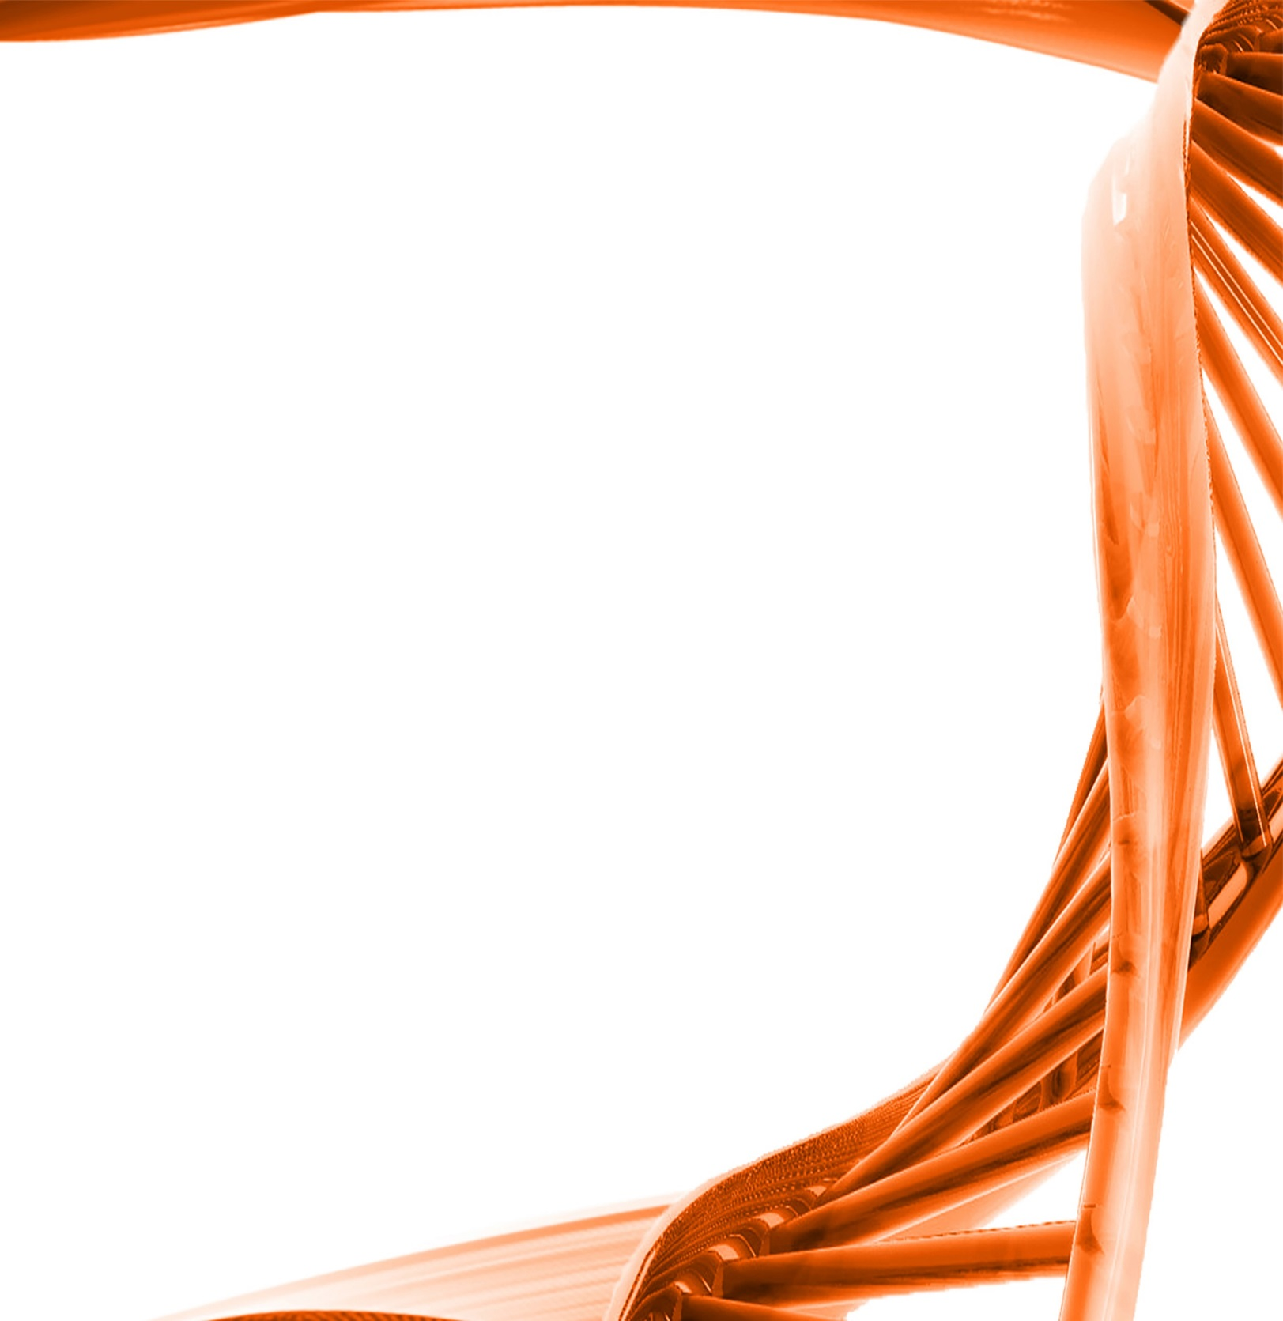

MICROBIOLOGY & MOLECULAR GENETICS
Departmental Journal Club
MICR 6120

Monday
February 13th, 2016
11:30am-12:20pm
RM 122 Classroom Bldg.

Presented by
Amal Yahya
Accelerated Master’s Student

Title: The improved antibody response against HIV-1 after a vaccinationbased on intrastructural help is complemented by functional CD8+Tcell responses
Authors: Michael Storcksdieck genannt Bonsmann, Thomas Niezold, Drew Hannaman,Klaus Überla, Matthias Tenbuscha
Despite more than three decades of intense research, a prophylactic HIV-1 vaccine remains elusive.Four vaccine modalities have been evaluated in clinical efficacy studies, but only one demonstratedat least modest efficacy, which correlated with polyfunctional antibody responses to the HIV surfaceprotein Env. To be most effective, a HIV-1 vaccine probably has to induce both, functional antibody andCD8+T cell responses. We therefore analyzed DNA/DNA and DNA/virus-like particle (VLP) regimens fortheir ability to induce humoral and cellular immune responses. Here, DNA vaccination of mice inducedstrong CD8+responses against Env and Gag. However, the humoral response to Env was dominatedby IgG1, a subclass known for its low functionality. In contrast, priming only with the Gag-encodingplasmid followed by a boost with VLPs consisting of Gag and Env improved the quality of the anti-Envantibody response via intrastructural help (ISH) provided by Gag-specific T cells to Env-specific B cells.Furthermore, the Gag-specific CD8+T cells induced by the DNA prime immunization could still protectfrom a lethal infection with recombinant vaccinia virus encoding HIV Gag. Therefore, this immunizationregimen represents a promising approach to combine functional antibody responses toward HIV Envwith strong CD8+responses controlling early viral replication.

